

**A PROJECT ON WELLNESS AND FITNESS BLOGS WEBSITE**

The final project in PGP java

By

**KANIYAN PANDIARASAN K R200002100292**

**Batch code 210167**

**Date of Submission 15/03/2021**

Under the guidance of

**Ms. LOPAMUDRA BERA**

# **CERTIFICATE**

***This is to certify that this report, titled Wellness & Fitness Blogs website embodies the original work done by Kaniyan Pandiarasan K, in partial fulfilment of his course requirement at NIIT.***

**Coordinator: Ms. Lopamudra Bera**

# **ACKNOWLEDGEMENT**

***It gives me great pleasure in expressing my gratitude to all those people who have supported us and had their contribution in making this project work possible. First and foremost, I must acknowledge and thank the Almighty for blessing, protecting and guiding me throughout this period.***

***I express my profound sense of reverence to my Coordinator Ms. Lopamudra Bera, for her constant guidance, support, motivation and untiring help during the course of my project work. She has given us enough freedom during our project work, and she has always been nice to us. I am thankful to the Almighty for giving us a teacher like her.***

# **ABSTRACT**

***This Project will mainly use for professional networking, allowing registered users to post blogs and their information is organized and easily accessible to all registered users.***

***Users will register themselves in the register form and fill in their professional details. And Admin can be able to manage all the process from activating the registering user to approving a blog posted by the user.***

# **CONFIGURATION**

* *Hardware*
  + - *Core i3 Processor 2.10 GHz x64 bit*
    - *8 Gigabytes of RAM*
* *Operating System*
  + - *Windows 10 Home*
* *Software*
  + *Eclipse IDE*
    - *JAVA*
    - *Spring boot*
    - *Hibernate*
    - *MYSQL*
  + *Angular*
    - *Html*
    - *Typescript*
    - *SCSS*
    - *jQuery*

# **TABLE OF CONTENTS**

Chapter 1 – Introduction

* 1. Objective
  2. Case Study

Chapter 2 – Project Requirement Specification

2.1. Statement of requirement

Chapter 3 – Project Analysis

3.1. Project Plan

3.2. Business Model

3.3. Project Flow

4.4. Dispatcher Servlet Diagram

Chapter 4 – Project Design

4.1. Angular Lifecycle Diagram

4.2. User Interface Design

4.3. Data Structure Model

4.4. Data Model

4.5. Project Structure

Chapter 5 – Project Testing

5.1. Test Cases

5.2. Personal Observation

# **OBJECTIVE**

This Project will mainly use for professional networking, allowing registered users to post blogs and their information is organized and easily accessible to all registered users.

Users will register themselves in the register form and fill in their professional details. And Admin can be able to manage all the process from activating the registering user to approving a blog posted by the user.

# **CASE STUDY**

I worked on this project for four weeks and I needed to deliver a responsive website based on my own vision, research, findings and the process that I have learned throughout the program.

As fitness is increasingly becoming mainstream and a large percentage of people are working or at least try working towards their physical and mental health, this space can be tapped to make people get onboard much easily.

And I personally do exercises and be on my diet plan every day. So, I wanted share my thoughts towards fitness and wellness through a website, so that that will help so many people to follow perfect diet plans and workout tips and also, I can learn more from others thoughts.

I started working on the design that the user can interact and use the facilities seamlessly. I have gone through lot of similar websites, so that I can prepare myself to create a website with so many features than they have.

This web application will be built for helping people to practice healthy habits on a daily basis to attain better physical and mental health outcomes by providing valuable fitness tips on nutrition and diet, muscular strength.

# **STATEMENT OF REQUIREMENTS**

The project will comprise of many features. Anyone can able to get registered with this website and can have all information regarding fitness and wellness at one stop. User can able to sort out their daily food intakes to stay healthy.

The user can able to upload their photos on their profile. They can also post their thoughts as a blog and other users can interact with posted blogs to stay connected. Anyone can help someone by writing their own blogs on the website.

Users can view only those blogs which are approved by the admin and this enhances the quality of blogs shared by the user. Because, anyone can mislead the users by posting fake information.

Admin have the control of everything on the website. Admin can able to update the status of the user, activate or deactivate the registering user and deleting the user from the website.

User can able to interact with the posts by liking that blog and likes will be counted and displayed on the profile page of every user.

The user will be having access to tons of blog posts that keep them motivated and allows them to form a better habit for weight loss, weight gain, to keep their body healthy, to stay inspirational and other essential stuffs.

Wellness and Fitness Blogs will provide powerful tools that make it easier for anyone to live a heathier life and improve your overall health and fitness with our family of blogging community.

# **PROJECT PLAN**

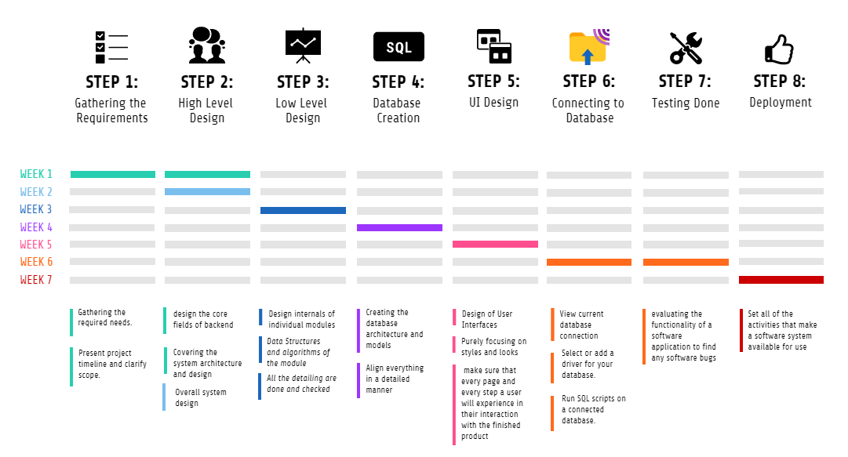

# **BUSINESS MODEL**

In the abovementioned model is that the overall functionality model of the application that we have already discussed in the previous chapter.

# **PROJECT FLOW**

# **DISPATCHER SERVLET DIAGRAM**

Response

Request

Model

Response

View

View Name

Request

Model & View

Controller

Request

View

Controller

Handler Mapping

Dispatcher Servlet

View Resolver

# **ANGULAR LIFECYCLE DIAGRAM**

**DOM**

**Loaded into DOM**

**Unloaded from DOM**

Component Instance

ngOnChanges()

ngOnInit()

ngDoCheck()

Component Instance

Component Instance

ngOnDestroy()

Occurs only once

Everytime there is a change in the input

Everytime there is a change detection and manually triggers it

Occurs only once

# **USER INTERFACE DESIGN**

The user interface (UI) is the point of human-computer interaction and communication in a device. This can include display screens, keyboards, a mouse and the appearance of a desktop. It is also the way through which a user interacts with an application or a website.

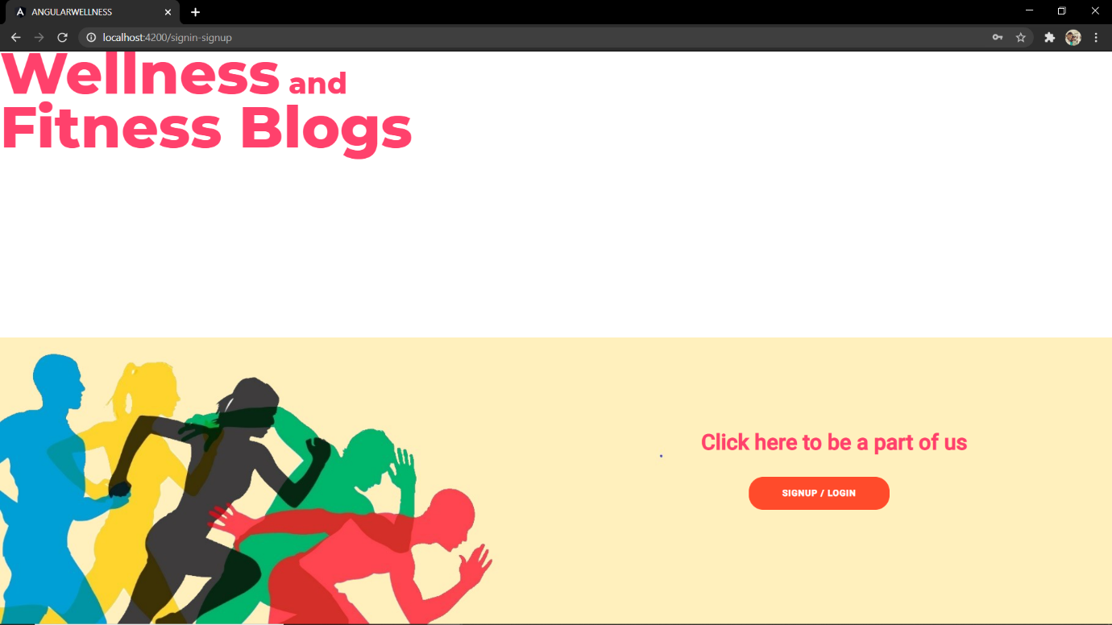

This is the landing page of the website. When the application starts, this is the first page that you can get. Here you will see a nicely designed landing page that has a title on the top and a button on the bottom of the page.

That button will navigate us to the signup or sign in page where you can enter your credentials to login or register.

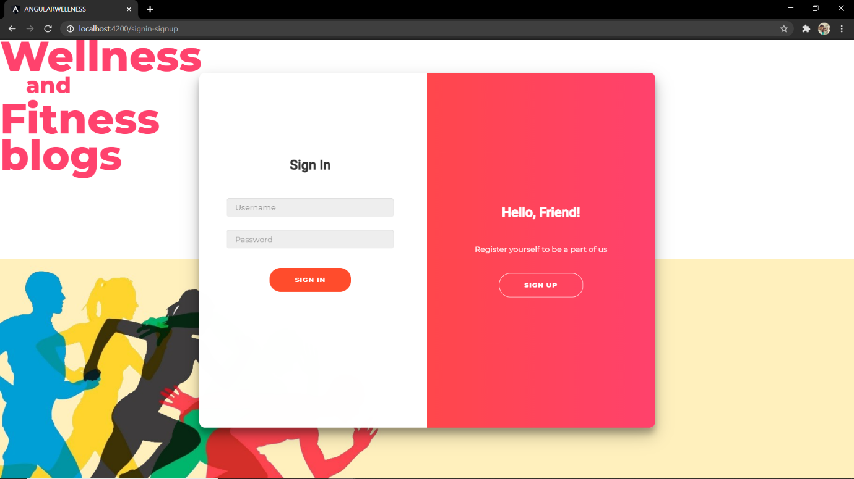

This the sign in / signup page. When you click that signin/signup button, this container will pop up with a smooth transition. Here, you have two buttons. Before you sign in, you need to be get registered with the community. Once the user click on the sign up button, it will slides to the left and opens the register component where you can able to register yourself by filling up the information.

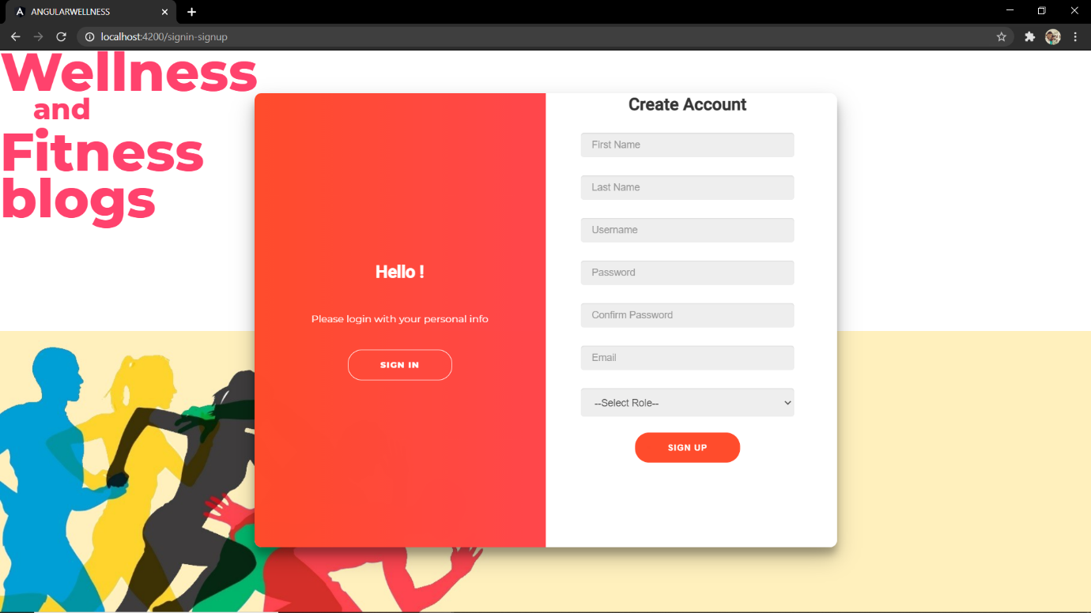Once you get the register section, there you will see the textboxes that are yet to be filled by user. And, if the user skips any details, then the user cannot sign up. Each and every detail have to be filled by the user before clicking on the signup button.

If the user skips any field then it will show the required fields.

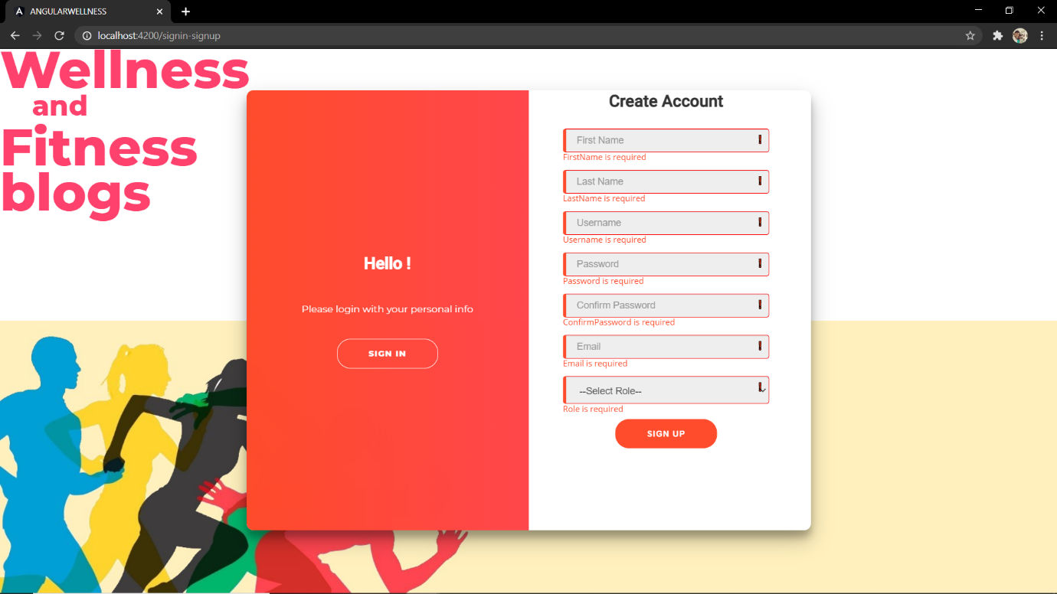

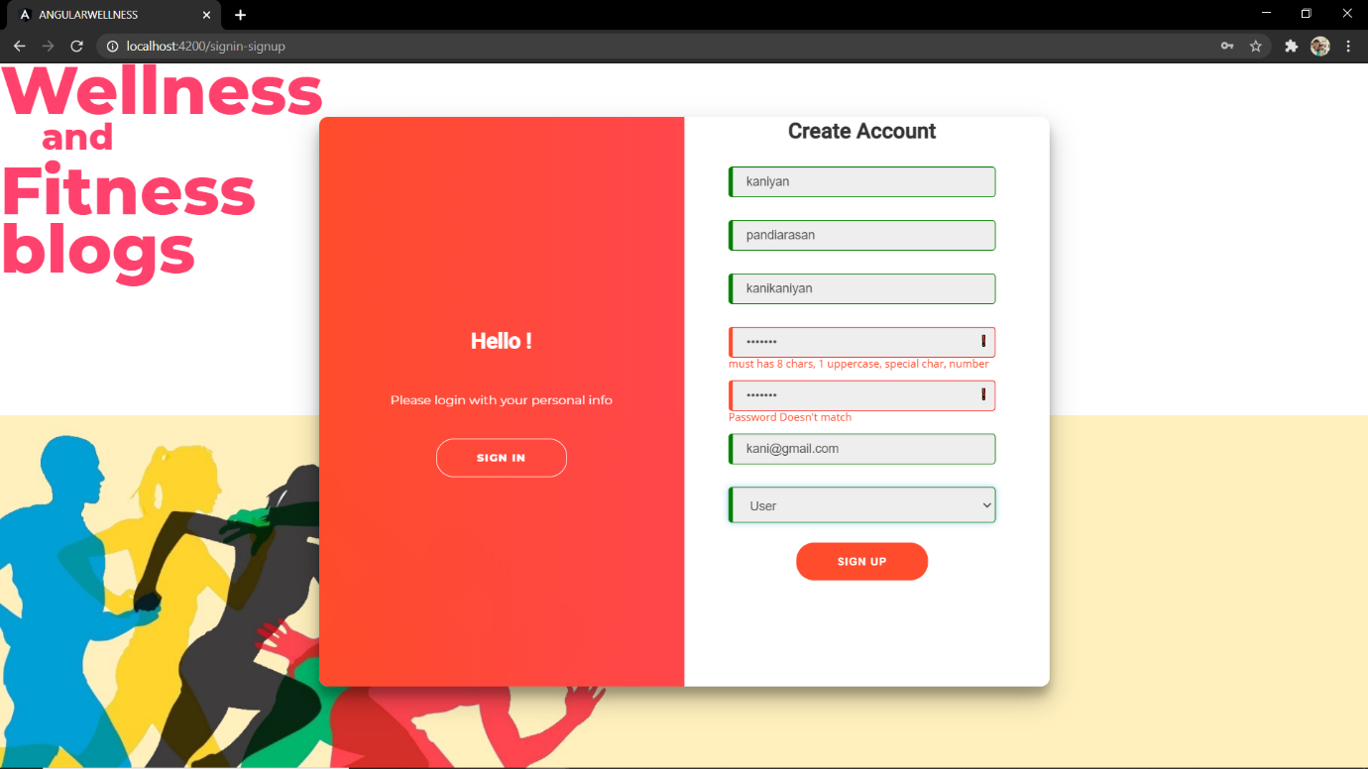

It also validates the password field. It will check whether the user enters the desired password or not and both the fields of the password matches. And once the required details are filled, the user can register themselves by clicking on the signup button.

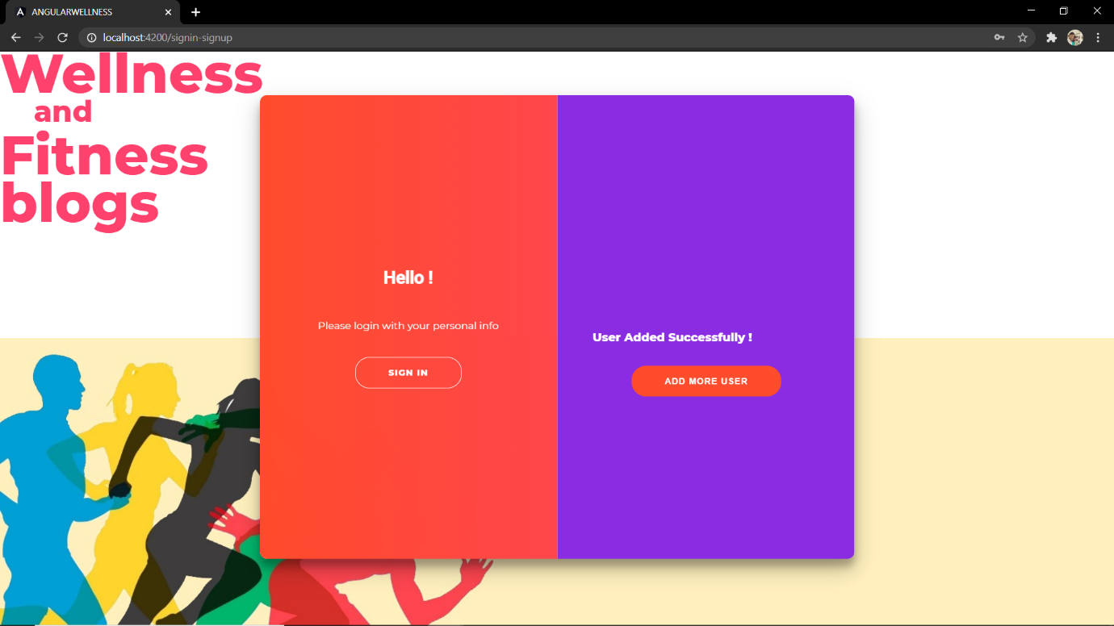

You can also add multiple users by clicking add more user button. Once you got successfully registered, the admin has to activate your profile to login.

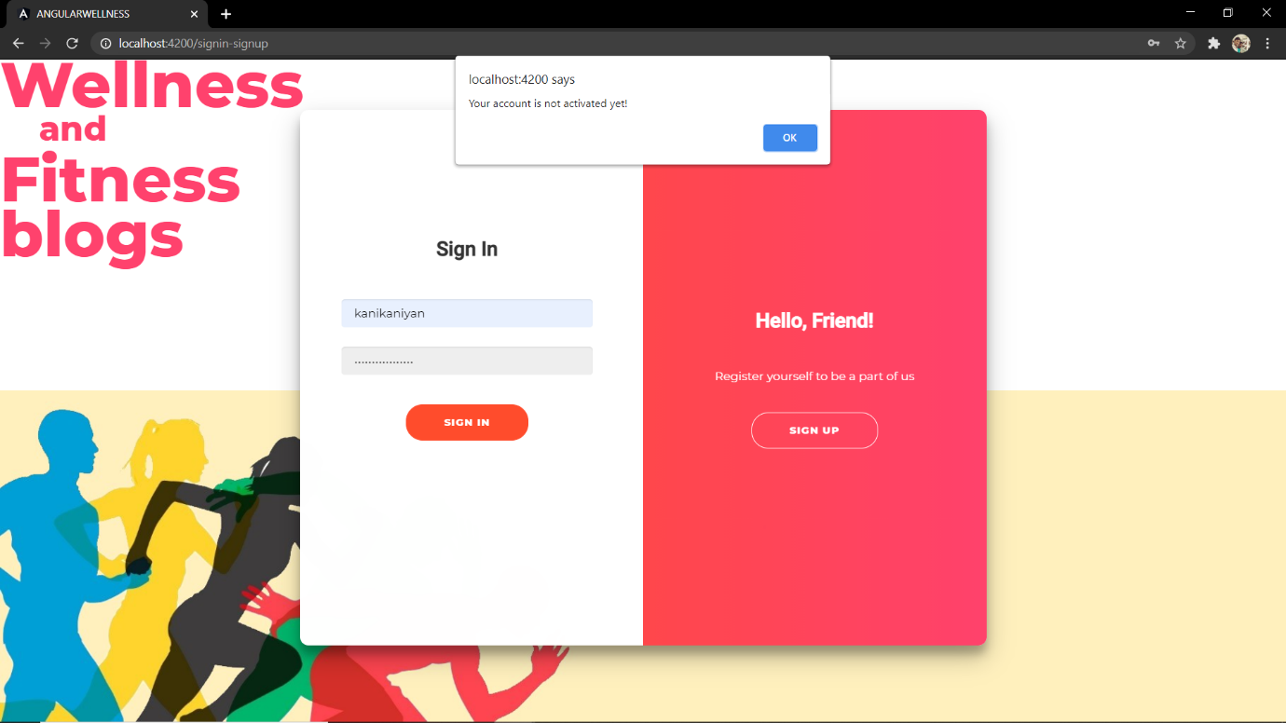

If the user tries to login before activation, it will show an alert box titled “Your account is not activated yet!”.

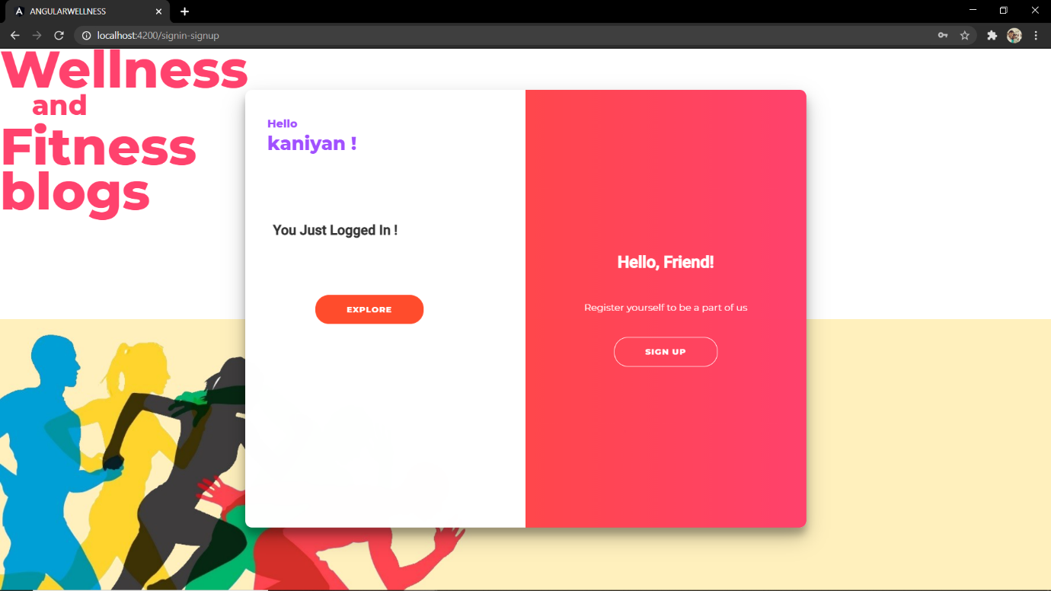

When your profile gets activated, you can login to the portal by entering your credentials. It will authenticate your credentials and grants you the access to go in. You can surf through your profile by clicking the explore button.

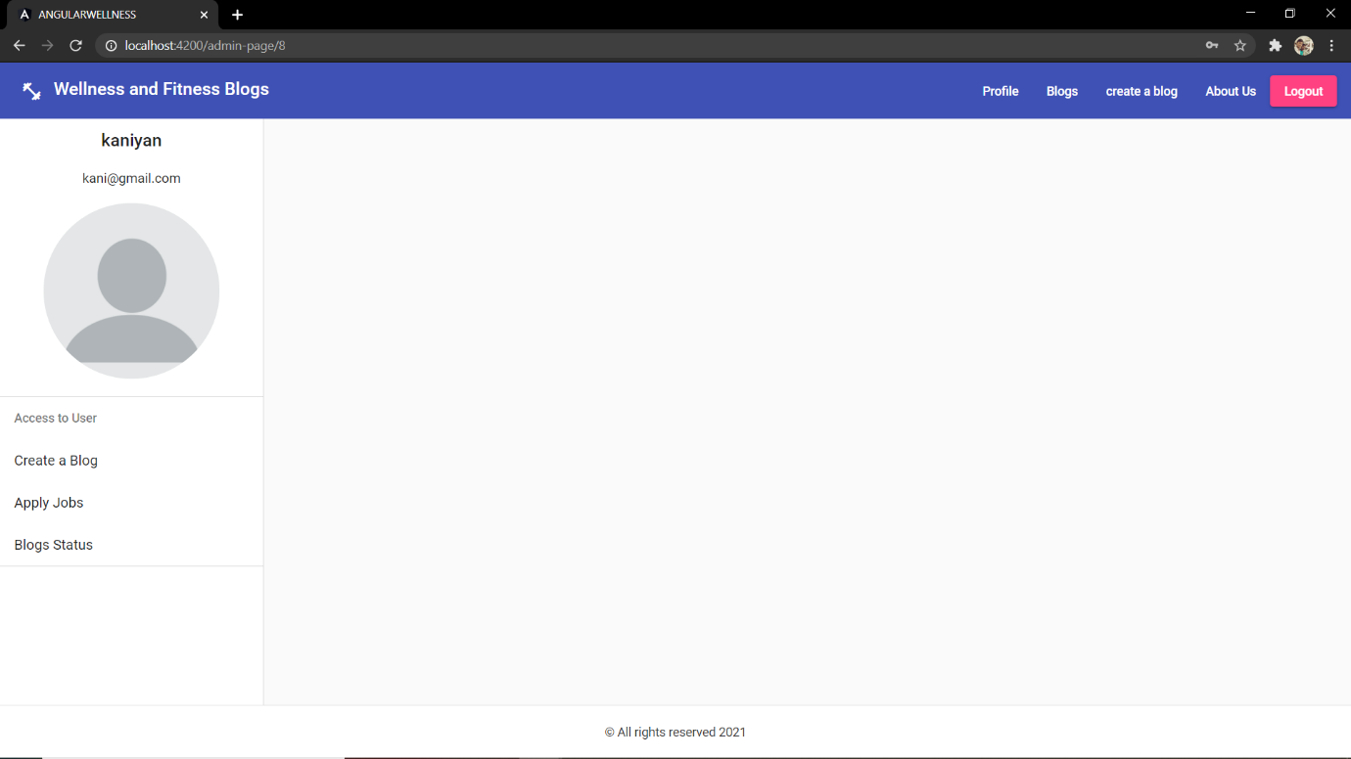

After clicking the explore button, you will be navigated to your portal. This is the page you will get see first. Here you will see lot of things you can do. On the navigation bar, you got a profile button, blogs, create a blog and about us, logout buttons. In the side navigation bar, you have your username and email followed by profile photo. You have blog status bar to check your blog status. You can toggle the sidebar by clicking the icon that you will found on the top left corner.

We will see every component and how it works.

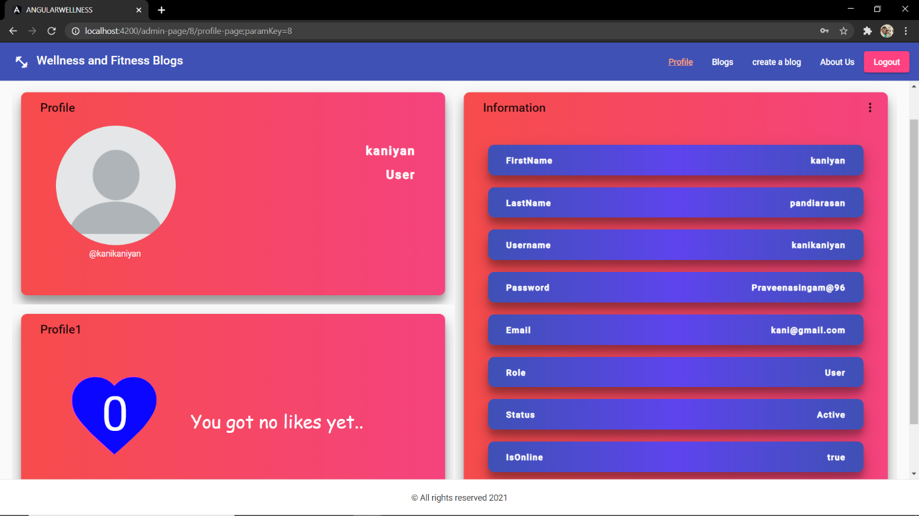

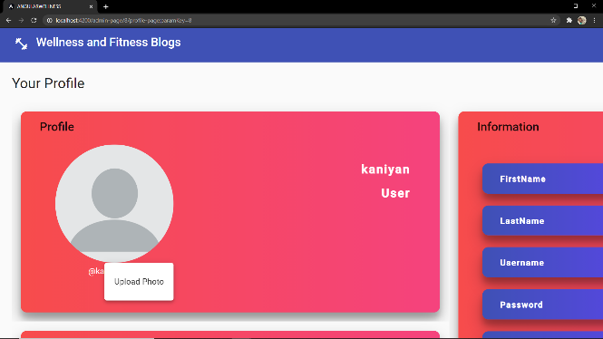 This is your profile page interface. In the first card you have your name, role and profile picture. In the information card, you have your personal details. In the profile1 card, there is a like icon which actually counts how much likes you have got from your blogs.

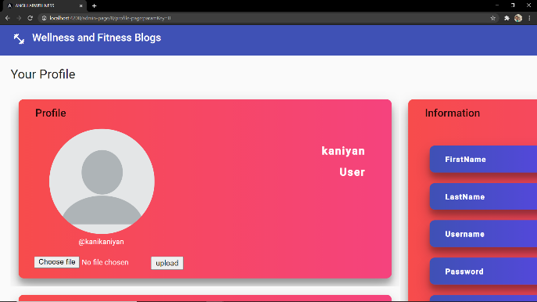

You need to click on the profile picture to upload a photo. By clicking the upload photo option, you will be asked to choose a photo from the system. After selection, you can upload your photo.

And the interface will look like this as below.

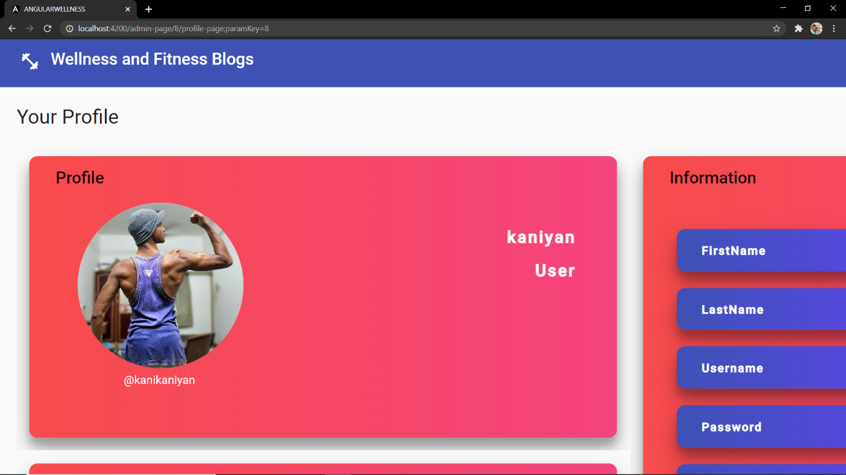

Next, let’s explore the information card. There is a vert icon on the top right corner. By clicking that, the user can able to edit or update their information.

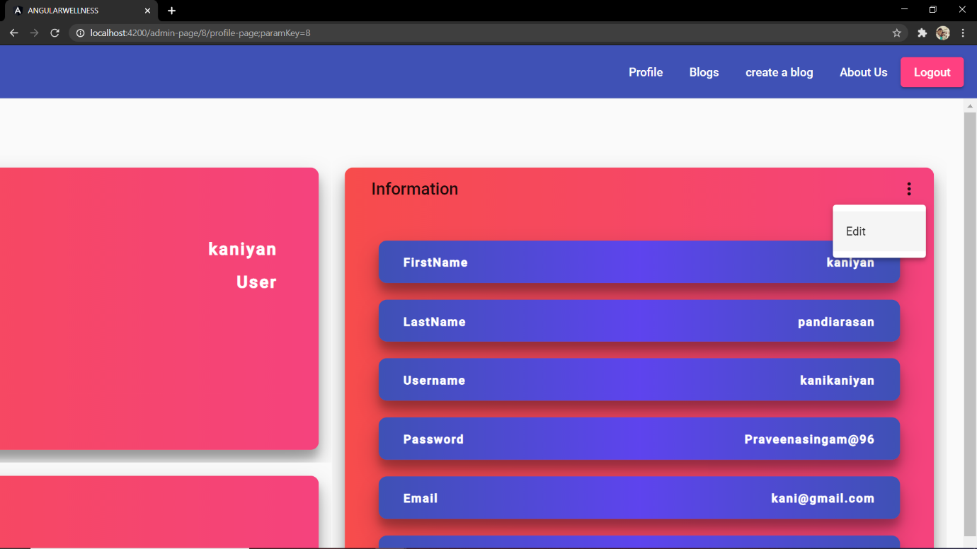

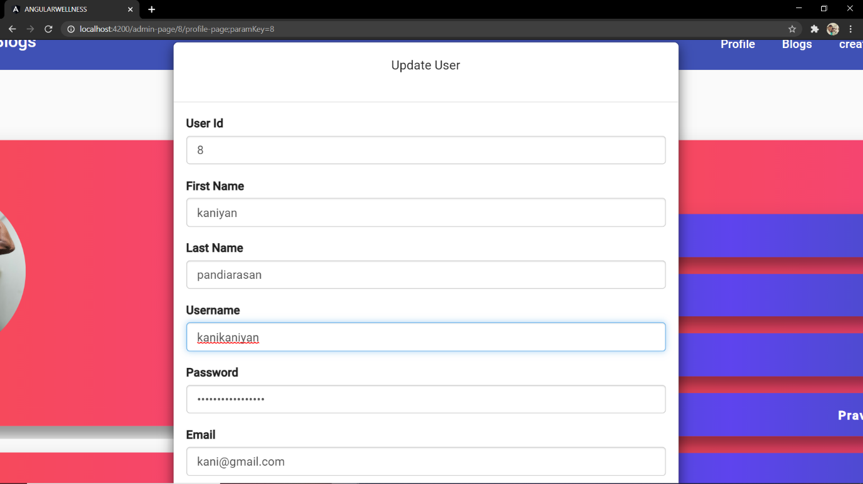

You can update your profile here.

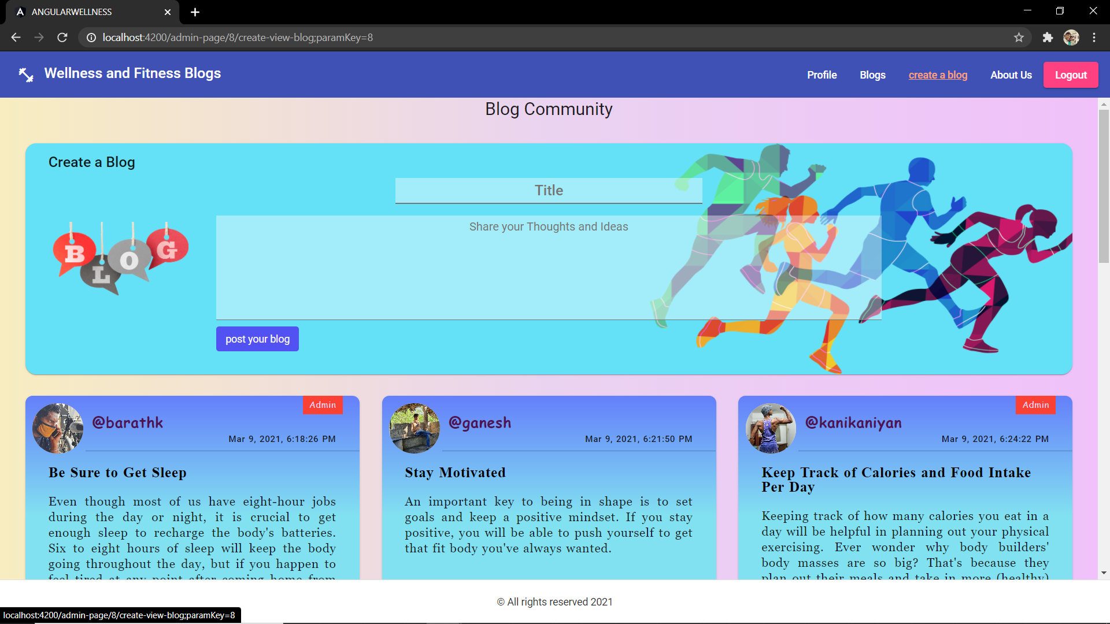

This is the blog section. Here, you will see a lot. First card is a create a blog portion. In here, you just have to type your thoughts or share your experience of your fitness journey. Once you written all, just click the post your blog button.

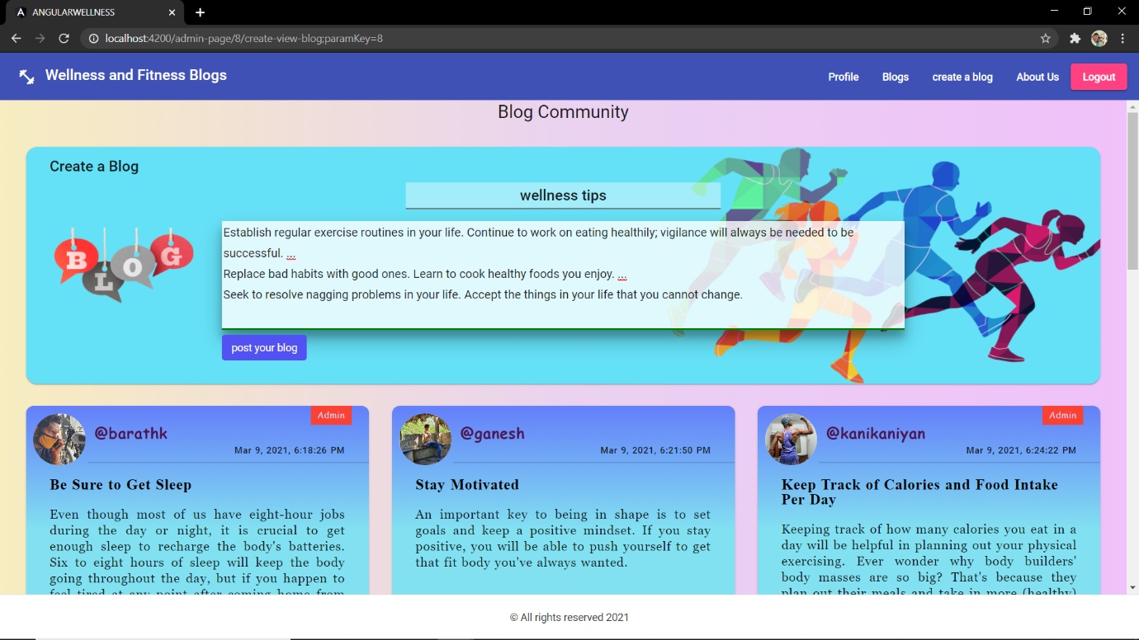

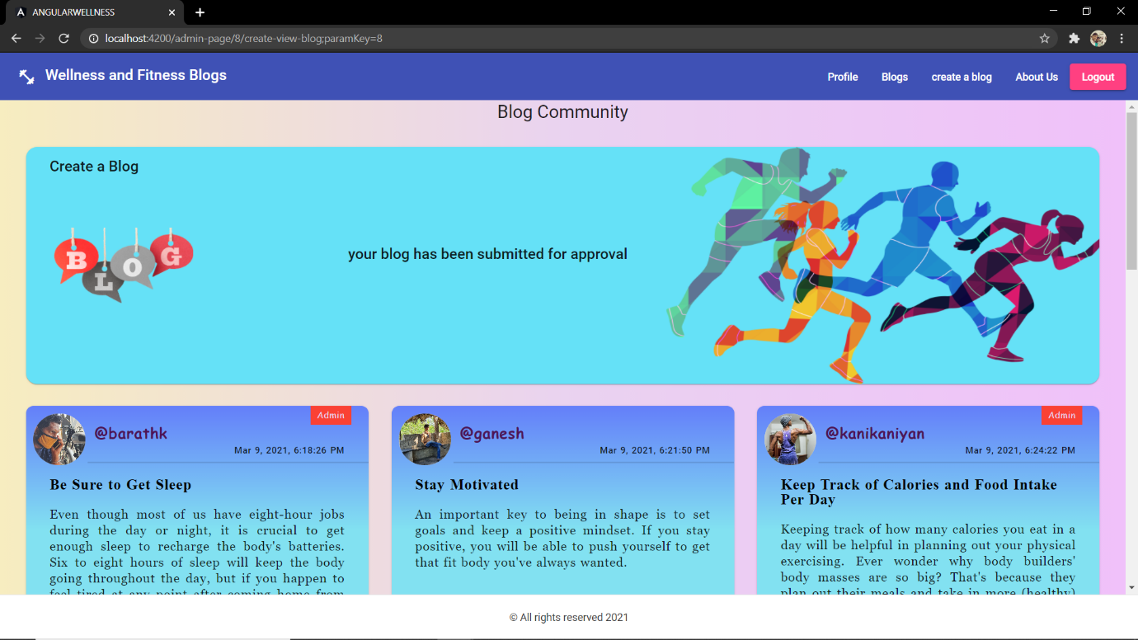

Once you click on the post button after you described your blog, that will be submitted for the admin approval. You can able to check your status on the blog status option by toggling the side bar.

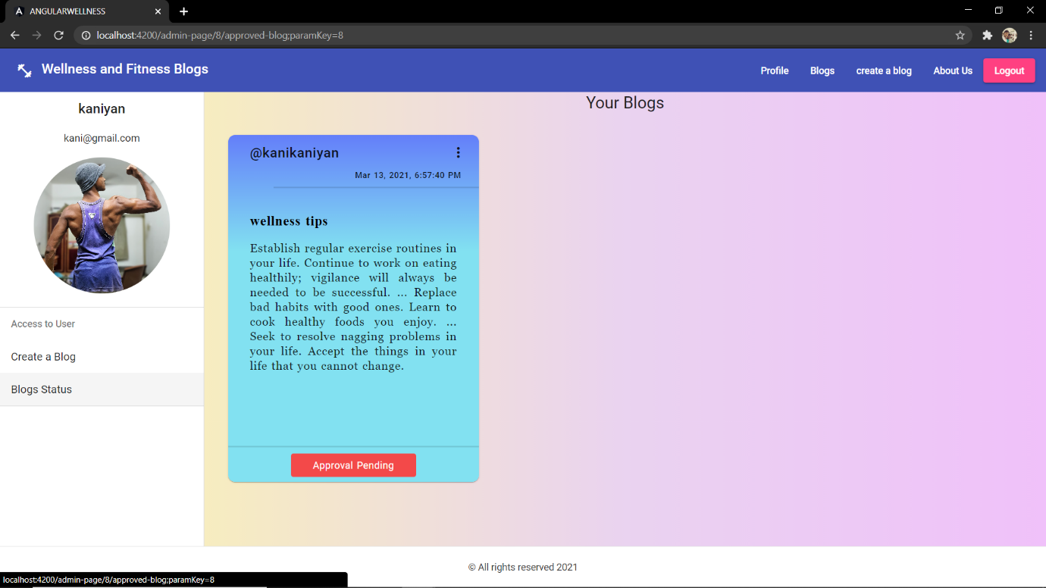

It shows you that Approval pending for your blog. As soon as the admin approves your blog, the status will be changed to “Approved”.

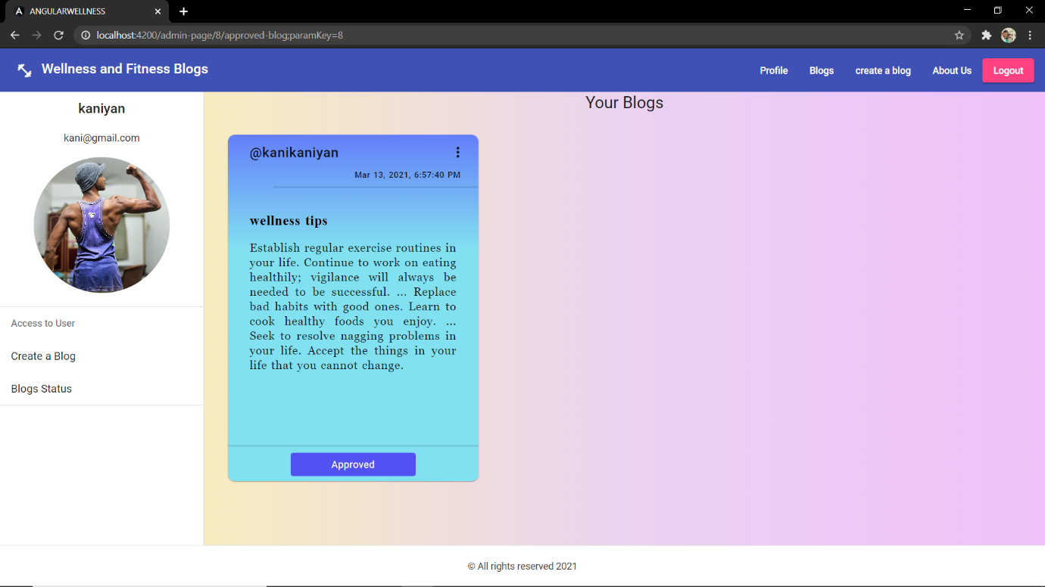

Your blog has been approved by the admin. So, the change reflected here. Now your blog has been posted on the main page. There you can scroll and check your blog.

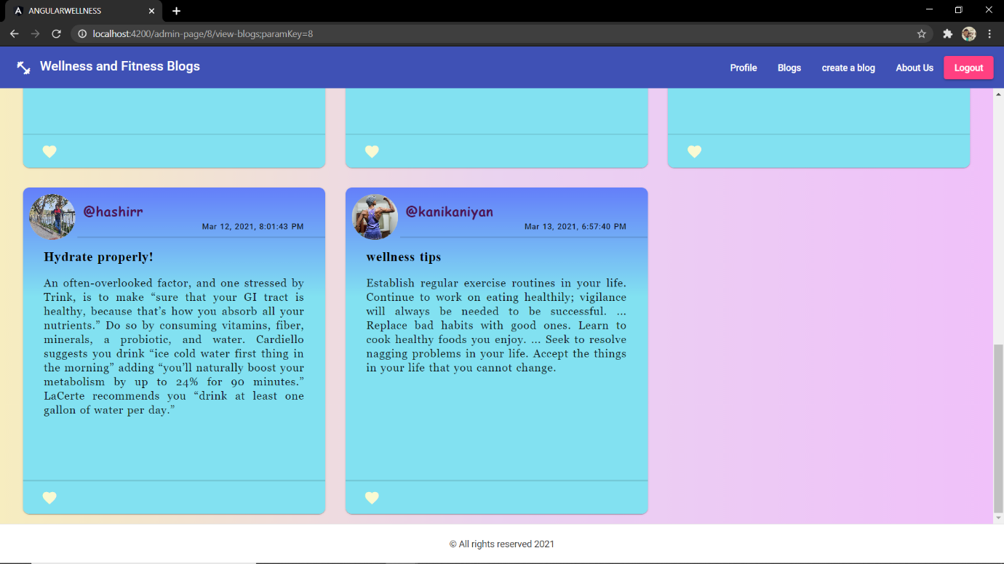

And your blog has been posted successfully.

You can also interact with other’s blogs by giving them a like and you can give a like to your own blogs also. Whoever likes your blog, that will be counted and displayed on your profile.

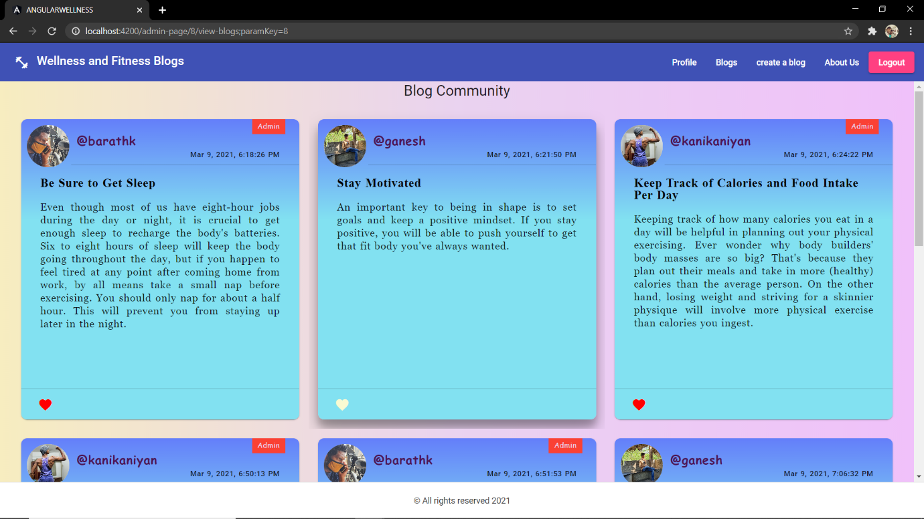

You can like a blog or unlike a blog.